AO_Tweaker

Weapon and item positioning tool for Survival Game Kit v2

# Overview

AO_Tweaker was created to make the process of aligning holdables in SGK a little easier and more certain. Since UE 4.26, direct manipulation of FirstPersonAO and ThirdPersonAO, while still possible, seems to be difficult to use reliably. Why this is, isn’t entirely clear, but the problem does seem to exist for some people.

AO_Tweaker offers **two modes of adjustment**. Coarse adjustment is done by dragging and/or rotating the tweaker itself in the scene while ejected from the player pawn. Fine adjustment is done through a set of sliders which can be enabled/disabled at any time.

AO_Tweaker provides a **unified location** for the adjusted relative transform which just makes it a little bit easier to copy location and rotation values for pasting into the IK values of the item being tweaked.

AO_Tweaker also **automatically switches character meshes on and off** depending on the current camera view.

Finally, AO_Tweaker **disables thirst and hunger** on the player character so you can take your time tweaking ik offsets without worrying about dying in the middle of a session.

My data wrangler has found this method to be faster and less error prone which makes him very happy. Hopefully others will find this useful as well.

**NOTE: This readme assumes that you have already watched the Defuse Studios tutorials on how to create an item or weapon and adjust its hand IKs. This tweaker doesn’t replace that procedure. It merely makes parts of it a little more convenient.**

# Installation

Just open AO_Tweaker.zip and drag the AO_Tweaker folder anywhere in the Content folder of your project.

# Using the Tweaker

To use the tweaker, just drag the BP_AO_Tweaker actor into the scene. It can be helpful to position it at roughly character chest height.

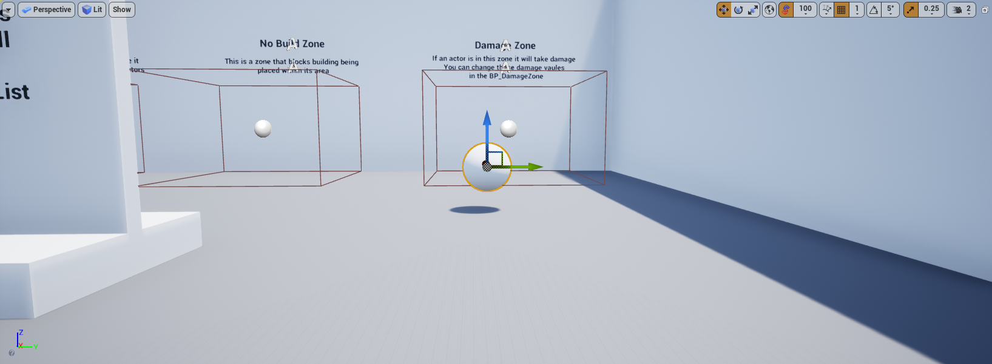

When you run the game, a panel will appear at the top of the viewport. This is the fine adjustment panel and it’s disabled by default.

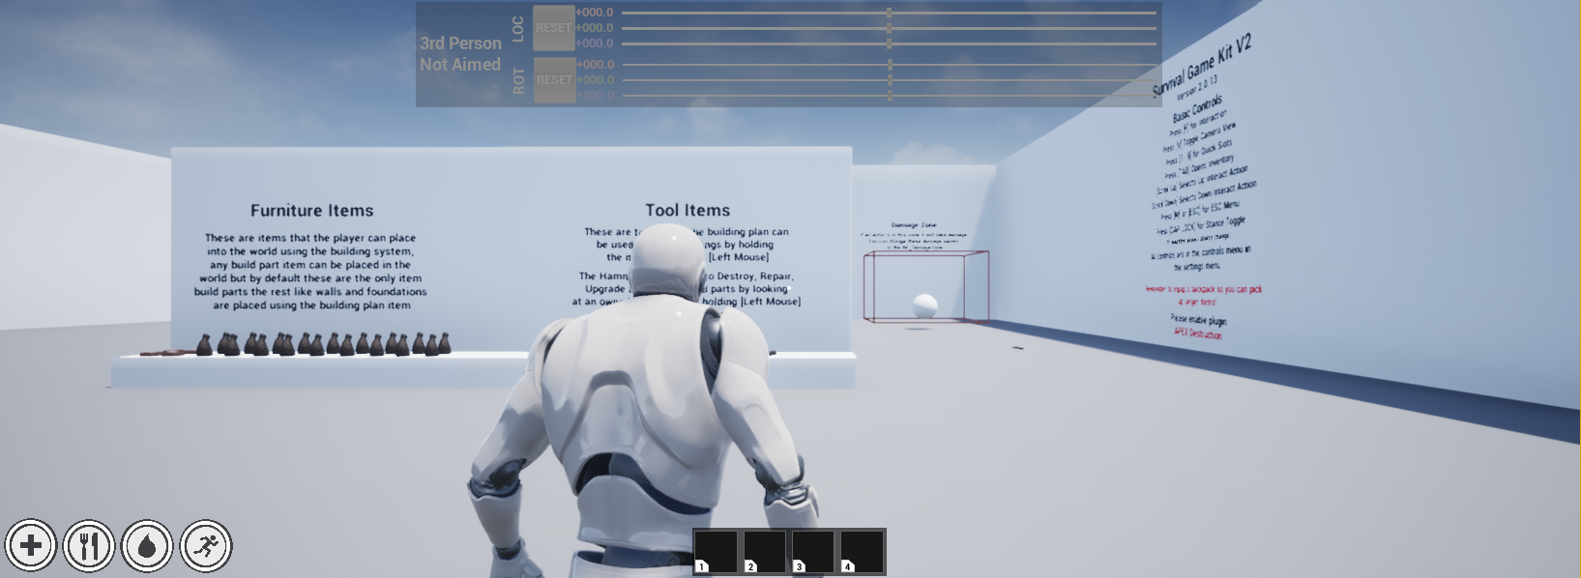

Pick up the item/weapon you’re tweaking and position the player character close to the tweaker’s sphere.

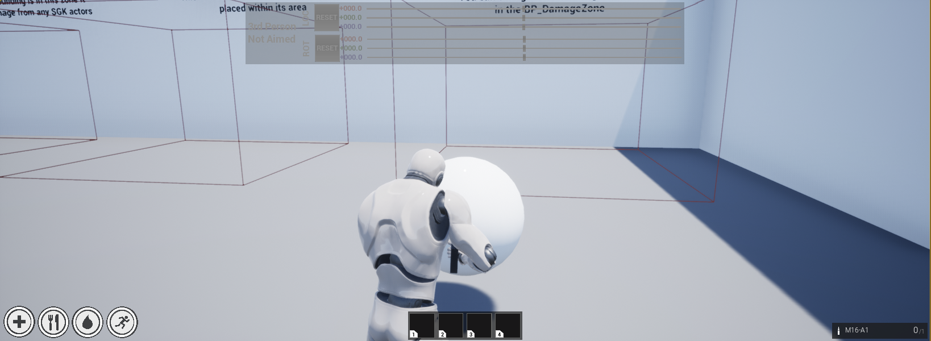

At this point, you should be ready to adjust the ik’s for your item.

# Enabling and Disabling the Tweaker

Press [Page Up] to toggle the tweaker on and off. Turning off the tweaker shuts it down completely, except for watching for another press of [Page Up]. It also hides the fine adjustment panel.

# Enabling and Disabling the Fine Adjustment Panel

Press [Page Down] to toggle the fine adjustment panel. Enabling the panel puts the game into UI only mode. Disabling the panel restores normal game operation.

# Coarse Adjustment

To do a coarse adjustment, set the character’s view for the IK offsets you want to tweak. Eject from the pawn and position the camera as you normally would. In the World Outliner, search for AO_Tweaker and select it.

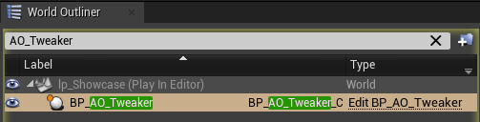

Then, under the Details panel, find AOTracker. Select this. The relative transform of this actor should always reflect the relative transform of the AO that’s relevant to whatever camera view and aim state the character is in. This makes it a little easier to avoid copying the wrong values into the IK settings you’re adjusting.

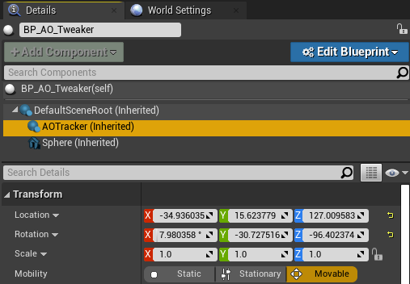

Now drag and rotate the tweaker sphere to position the item. You’ll see the sphere snap back to its starting location and rotation whenever you stop dragging. This is normal and the hand IK’s won’t be affected.

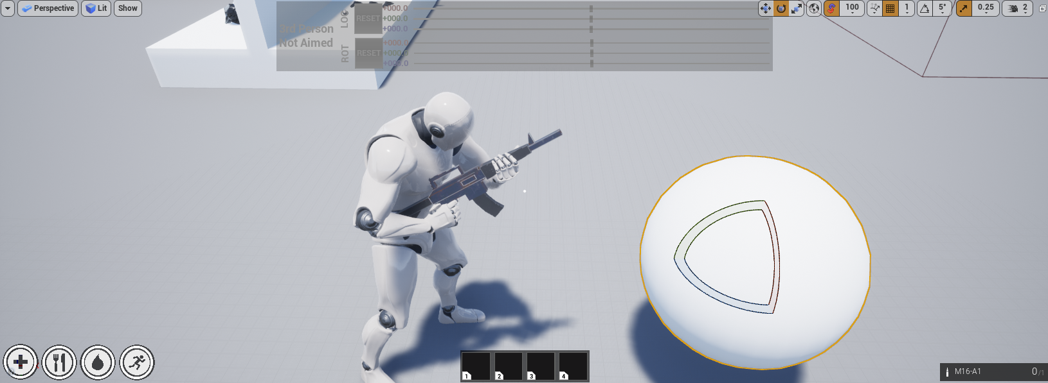

When you’re happy with the positioning, just copy the location and rotation values from AOTracker into your item’s IK values.

**NOTE: By default, the fine adjustment panel only offers a range of +/- 30 degrees and +/- 25 centimeters. This means that if your coarse adjustment is too far away from your final desired orientation you may have to go back and redo your coarse adjustment. Alternatively, you can simply save the IK values when you’re as close as you can get, rerun the game and continue adjusting. The fine adjustments are always relative to the item’s starting position so you can do successive fine adjustment sessions to get the alignment you want.**

# Fine Adjustment

Turn on the fine adjustment panel by pressing [Page Down]. This sets the game input mode to UI only, which is convenient for copying IK values.

Use the LOC and ROT sliders to adjust the item’s hand IK alignment and then copy Location and Rotation from the AOTracker’s relative platform into your item’s IK values.